AI · MARKETS · SYSTEMATIC RESEARCH

AI in Financial Markets
Machine learning, signal extraction, and risk monitoring in modern financial research

Paolo D’Ascenzi
Research Note · 2026

This paper examines how artificial intelligence is reshaping financial research, from data processing and signal extraction to portfolio construction, execution, and real-time risk monitoring. It focuses on where machine learning can add genuine value, where it can create false confidence, and why disciplined validation remains central to investment research.
Illustrative examples and figures are explicitly labelled. They are not presented as proprietary backtest results or investment performance.

Abstract
Artificial intelligence is becoming part of the infrastructure through which financial information is collected, interpreted, and transformed into decisions. The most visible manifestation is generative AI, but the deeper transformation involves machine learning, natural language processing, neural networks, anomaly detection, alternative-data processing, automated feature extraction, and increasingly sophisticated decision-support systems. The relevant question for investors is therefore not whether AI will replace traditional analysis. A more useful question is how AI changes the economics of information. Financial markets have always been information-processing systems: participants collect data, form expectations, allocate capital, update those expectations, and compete with others attempting to do the same thing more accurately or more quickly. AI reduces the cost of several parts of that process. It can process more information, identify nonlinear relationships, analyse unstructured data, monitor portfolios continuously, and generate probabilistic signals at a scale that would be impossible for an individual analyst. But these advantages do not eliminate the central difficulty of investing. Markets are adaptive. Relationships change, participants learn, signals decay, transaction costs matter, regimes shift, and sophisticated models can overfit historical noise. The result is a paradox: AI may make individual investment processes more sophisticated while simultaneously making markets more competitive and, under some conditions, more fragile. This note examines that tension and argues that the most durable role for AI is not as an oracle, but as a disciplined infrastructure for processing uncertainty.

Contents
1. Markets as information-processing systems
2. From traditional models to machine learning
3. Data, language and feature extraction
4. Signal generation and predictive modelling
5. Validation, overfitting and robustness
6. From predictions to portfolios
7. Risk monitoring and regime detection
8. Generative AI and fundamental research
9. Execution, transaction costs and market microstructure
10. Crowding, reflexivity and systemic risk
11. Governance, explainability and human oversight
12. A practical framework for AI-driven investment research
Conclusion
Selected references

1. Markets as information-processing systems
A financial market can be understood as a continuously updating mechanism for aggregating expectations. Every traded price is the temporary equilibrium between participants holding different beliefs about future cash flows, discount rates, inflation, growth, liquidity, positioning, regulation, and risk. The investment problem therefore begins as an information problem: what is known, what is believed, what is already reflected in the price, and where might the consensus be wrong?
For decades the process was predominantly human. Analysts read financial statements, economists interpreted macroeconomic releases, traders observed price action and order flow, and portfolio managers combined these inputs into decisions. Technology progressively altered each stage. Databases replaced paper archives; spreadsheets accelerated modelling; electronic exchanges automated execution; and quantitative strategies transformed security selection into rules. Machine learning extends this evolution by allowing systems to analyse information that is too large, too complex, or too unstructured for conventional workflows.
The central economic objective, however, has not changed. The investor is still attempting to transform information into a superior estimate of expected return and risk. AI changes the tools, the speed, and the scale of analysis. It does not change the fact that markets are competitive environments in which every useful edge attracts imitation and eventually decays.

The economics of information
If public information becomes cheaper to process, the price of basic analysis falls. A ten-page filing can be summarised instantly; thousands of transcripts can be compared in minutes; and software can continuously monitor a portfolio for changes in volatility, correlation, or news sentiment. The effect is similar to previous waves of financial technology: activities that once required scarce human labour become standardised and increasingly commoditised.
This has an important implication. AI can make an investor more capable without necessarily making that investor more capable relative to everyone else. If the same infrastructure becomes widely available, the minimum analytical standard rises. The edge then migrates toward differentiated data, superior research design, better execution, stronger risk controls, or a time horizon that other market participants are unwilling to adopt.

2. From traditional models to machine learning
Traditional financial modelling usually begins with an explicit hypothesis. The researcher chooses explanatory variables and imposes a functional form. A simple factor model, for example, can be expressed as:
Rᵢ,ₜ = αᵢ + β₁F₁,ₜ + β₂F₂,ₜ + … + βₖFₖ,ₜ + εᵢ,ₜ
Machine learning reverses part of this process. Instead of fully specifying the relationship in advance, the researcher defines the target, the information set, and the model class, allowing the algorithm to infer useful interactions from data. A generic prediction problem can be written as:
ŷₜ₊₁ = f(Xₜ ; θ)
Here Xₜ represents available features, f the model architecture, θ the learned parameters, and ŷₜ₊₁ the predicted outcome. The function may be a penalised regression, random forest, gradient-boosted tree, support vector machine, neural network, transformer, or an ensemble of multiple models.

Why finance is unusually difficult
Financial prediction differs from many machine-learning applications because the environment reacts to the predictions. A better image classifier does not cause cats to change appearance. A profitable trading rule, by contrast, attracts capital. The additional trading changes prices and can weaken the very relationship the rule exploited. This reflexive property creates a non-stationary target.
The signal-to-noise ratio is also extremely low. Daily asset returns contain large random variation relative to predictable structure. A useful model may therefore offer only a modest improvement in conditional probabilities. That can still matter if the payoff structure, costs, and diversification are favourable. Conversely, a model with impressive classification accuracy may lose money if errors are economically expensive.

Nonlinearity
Machine learning becomes particularly interesting when financial relationships are nonlinear. Moderate momentum may predict continuation while extreme momentum may precede reversal. Volatility may be benign in one regime and dangerous in another. Valuation can interact with quality, rates, or credit conditions. Flexible models can learn these interactions without requiring the researcher to specify each one explicitly. The same flexibility, however, is also the source of overfitting.
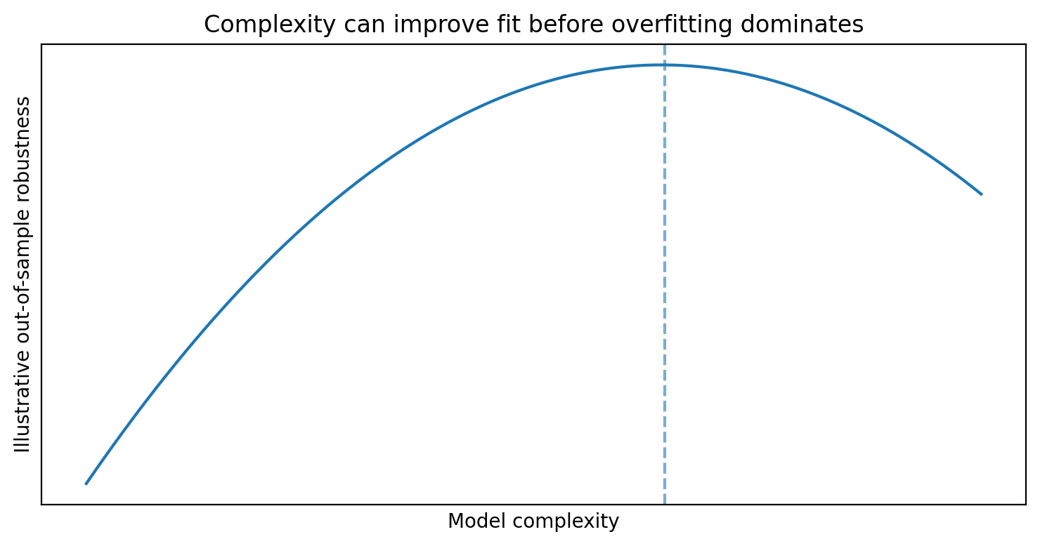
Figure 1. Conceptual relationship between model complexity and out-of-sample robustness. Illustrative only.

3. Data, language and feature extraction
The quality of an AI system depends heavily on the quality and timing of its inputs. In financial research, data can be organised into market, fundamental, macroeconomic, alternative, and textual sources. Market data include prices, returns, volume, spreads, volatility and order-book information. Fundamental data include revenue, margins, cash flow, debt, capital expenditure and valuation ratios. Macroeconomic data include inflation, labour-market indicators, yield curves, credit spreads, and economic-surprise measures. Alternative data include web traffic, app usage, satellite imagery, geolocation, shipping and hiring data. Textual data include filings, earnings calls, central-bank statements, news, broker research and social media.

Natural language processing
A large share of financially relevant information is expressed through language rather than structured numerical fields. Natural-language processing can transform that information into features that can be analysed systematically. A simple sentiment score might count positive and negative terms, but modern language models can identify uncertainty, optimism, evasiveness, topic changes, changes in guidance, references to supply constraints, and shifts in management tone.
The most useful signal is often not the absolute level of sentiment but its direction and context. A company can remain positive while becoming materially less positive than in previous quarters. That deterioration may matter more than whether the transcript is classified as positive or negative in isolation.
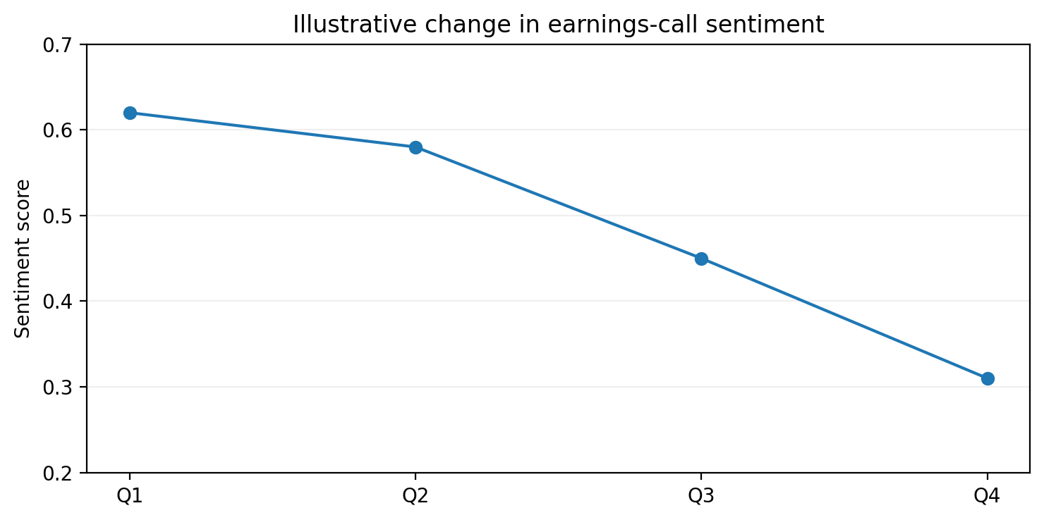
Figure 2. Illustrative deterioration in an earnings-call sentiment score across four quarters.

Feature engineering
A simple multi-input investment signal can combine momentum, valuation, volatility, sentiment and regime information. Standardisation allows features measured in different units to be compared:
zᵢ = (xᵢ − μᵢ) / σᵢ
A rule-based composite score could then be written as Sₜ = w₁zMomentum + w₂zValue − w₃zVolatility + w₄zSentiment + w₅zRegime. A machine-learning model can go further by learning nonlinear weights and interactions. For example, volatility may reduce expected return only when credit conditions are deteriorating, while positive sentiment may matter more when valuation is not already extreme.
The risk is that the model discovers correlations that are statistically strong but economically meaningless. For that reason, feature design should not be treated as a competition to maximise the number of inputs. Every feature should have a plausible mechanism, reliable timestamping, and evidence that its contribution survives outside the development sample.

4. Signal generation and predictive modelling
A useful AI investment system does not need to issue direct BUY or SELL instructions. In many cases a better architecture is Data → Probability → Portfolio Decision. The model may estimate P(Rₜ₊₅ > 0) = 0.64, after which the portfolio layer decides whether a 64% probability is attractive given expected payoff, downside risk, transaction costs, liquidity, correlation and existing exposure.

Accuracy is not profitability
Consider two hypothetical models. Model A predicts direction correctly 60% of the time, with an average winning trade of +0.4% and average loss of -1.0%. Its expected value is negative. Model B is correct only 53% of the time, but the average winner is +1.2% and the average loss -0.8%, producing a positive expected value. This example illustrates why machine-learning metrics cannot be evaluated independently of investment economics.
E[Trade] = P(win) × AvgWin + P(loss) × AvgLoss

Probability calibration
A model that claims an 80% probability should historically be correct roughly 80% of the time under comparable conditions. If its 80% predictions succeed only 57% of the time, the model is poorly calibrated. Calibration matters because investment systems often convert confidence into position size. Overconfident probabilities can therefore create excessive leverage or concentration even when classification accuracy appears acceptable.

Distribution forecasts
Point forecasts also hide important information. Instead of predicting an expected return of +1.5%, a stronger model can estimate a return distribution with mean, volatility, downside probability and tail risk. Portfolio construction cares about the entire distribution of outcomes. Two assets with the same expected return can require very different position sizes if one has substantially greater downside asymmetry.

5. Validation, overfitting and robustness
Overfitting is the central enemy of quantitative research. Suppose a researcher tests hundreds of indicators, dozens of lookback windows and multiple stop-loss, take-profit and portfolio rules. Some configuration will almost certainly look exceptional by chance. The more degrees of freedom the researcher introduces, the greater the probability that historical noise will be mistaken for structure.

Chronological validation
Ordinary random train-test splits are inappropriate for most market data because time matters. Future information must never leak into past predictions. A more realistic workflow separates training, validation and testing chronologically, and then rolls the process forward through time.
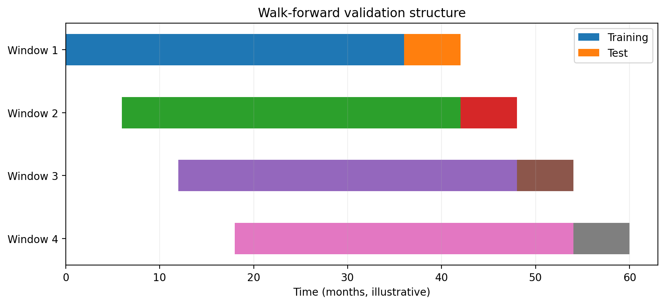
Figure 3. Illustrative walk-forward validation. Each test window occurs after the corresponding training window.
Walk-forward analysis is intentionally harsh. The strategy is repeatedly evaluated on periods that were unavailable during estimation. That makes it more likely to expose model instability before capital is deployed.

In-sample performance can be misleading
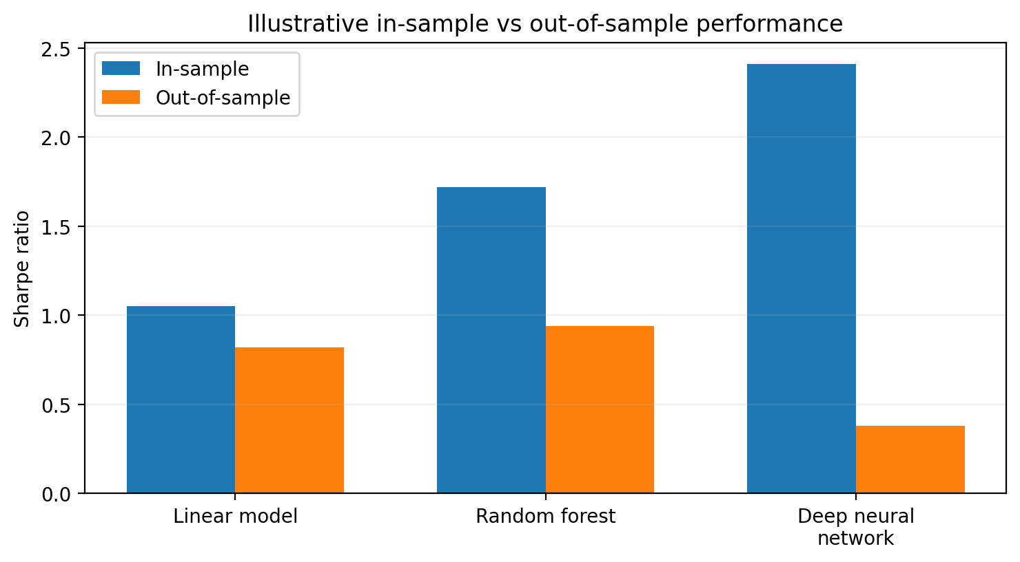
Figure 4. Illustrative comparison of in-sample and out-of-sample Sharpe ratios. Numbers are hypothetical.
A deep neural network can dominate the training sample and still perform poorly out of sample. This does not imply that complex models are inherently inferior. It means that flexibility must earn its place through genuine out-of-sample improvement. If a simple model and a complex model deliver similar performance, simplicity has practical value because it is easier to monitor, explain, stress test and maintain.

Data leakage and survivorship bias
Some of the most impressive backtests are created accidentally by using information that was not available at the time. Earnings reported in April cannot be used in a March prediction merely because they relate to the first quarter. Revised macroeconomic data should not replace the original release. Historical index tests should use constituents that actually belonged to the index at each point in time rather than today’s surviving members. Powerful algorithms exploit small information advantages aggressively, so data leakage can make AI systems look especially impressive while being completely invalid.

Parameter stability and cross-market tests
A robust strategy should not depend on a single magical threshold. If a mean-reversion rule works only at RSI < 27.3 and collapses at nearby values, the result is suspicious. Broader parameter stability suggests that the model captures a genuine behaviour. Cross-market validation provides another test: a concept that survives across multiple securities, sectors or regions is more credible than one that appears only in a single asset during a short period.

6. From predictions to portfolios
Prediction and portfolio construction are separate problems. A model can identify a group of attractive securities, but the investor still needs to decide how much capital to allocate to each one. Traditional mean-variance allocation can be expressed as:
max_w [ wᵀμ − (λ/2) wᵀΣw ]
AI may improve estimates of expected returns, covariance, tail dependence or regime probabilities, but optimisation also introduces estimation risk. Small changes in return forecasts can produce large changes in optimal weights. Practical portfolios therefore require constraints on single-name exposure, sector concentration, leverage, liquidity and turnover.

Prediction is not a decision
A robust architecture can be written conceptually as Prediction + Risk Rules + Portfolio Constraints = Decision. The model should not be permitted to convert a high confidence score directly into unlimited exposure. Position sizing should reflect both model conviction and uncertainty about the model itself.

Model diversification
Diversification can apply to models as well as assets. Momentum, mean reversion, valuation, sentiment and defensive models often perform differently across regimes. Combining them can reduce dependence on any single mechanism. A more advanced meta-model can estimate the current regime and adjust strategy weights accordingly, although each additional layer increases complexity and must be validated independently.

7. Risk monitoring and regime detection
AI may ultimately be more useful for risk monitoring than for precise return prediction. Risk problems often involve classification, anomaly detection and conditional forecasting: detecting volatility regime changes, identifying unusual correlations, monitoring liquidity deterioration, or recognising when strategy behaviour diverges from historical expectations.

Dynamic risk targeting
Suppose a portfolio normally operates at 12% target volatility. If volatility, correlations and liquidity conditions deteriorate simultaneously, the system may reduce its target to 9% or 6%. This is not an attempt to forecast the next price move. It is an attempt to adapt risk to the state of the environment.
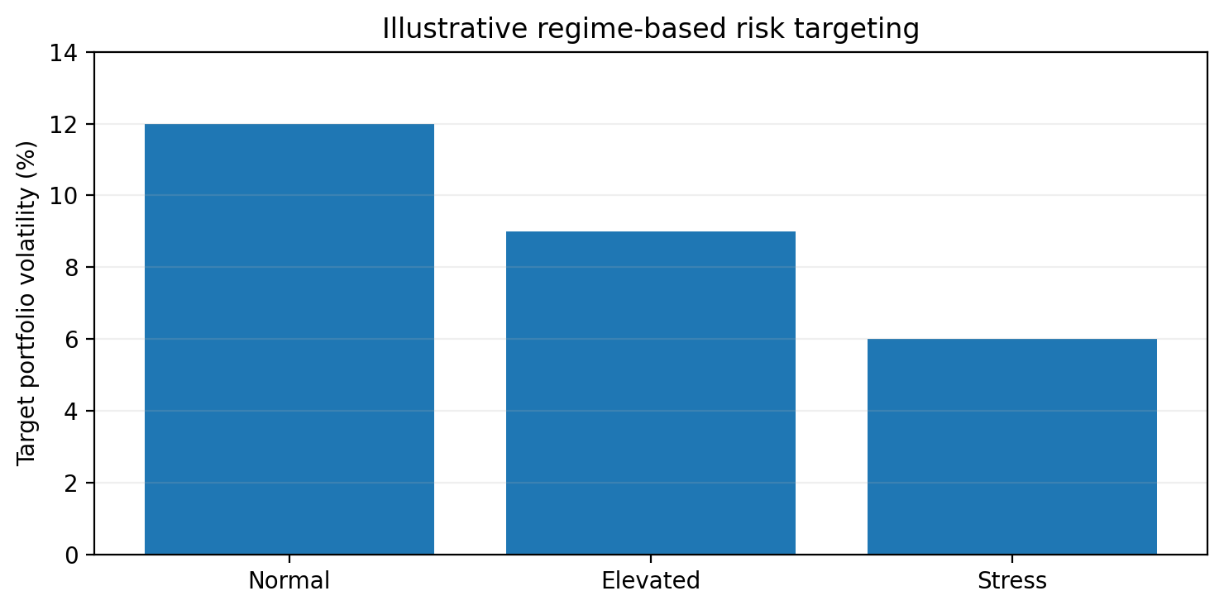
Figure 5. Illustrative target-volatility schedule across normal, elevated and stress regimes.

Regime detection
Markets can be viewed as moving between states such as risk-on, transitional and stress regimes. Unsupervised methods, hidden-state models, clustering, or supervised classifiers can estimate the probability of each regime from volatility, spreads, momentum, macro variables and cross-asset behaviour. Strategy weights can then become conditional on the state rather than assuming a single rule should work equally well in every environment.

Model decay
No quantitative strategy should be assumed permanent. A system should monitor rolling Sharpe, drawdown, hit rate, feature importance, average trade and regime dependence. The objective is not merely to ask whether the strategy works, but under which conditions it stops working.
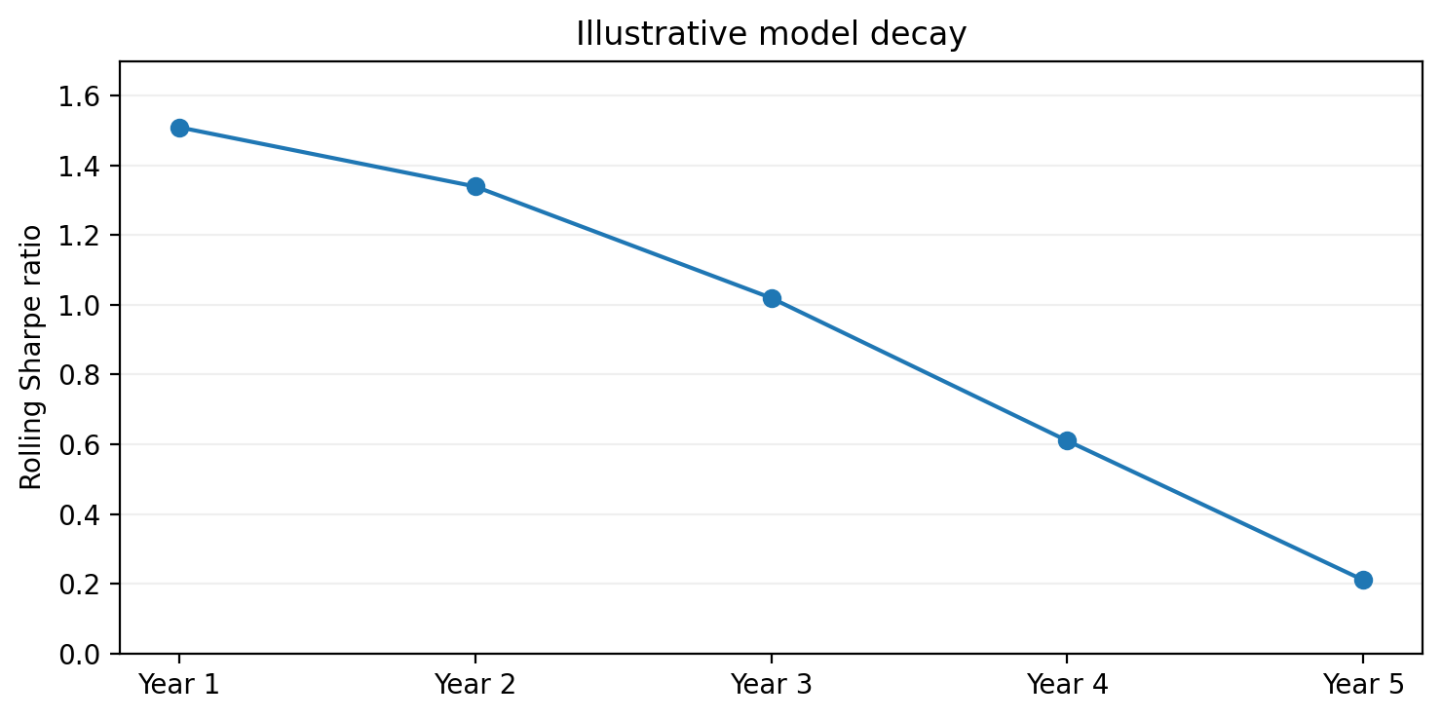
Figure 6. Illustrative model decay across five rolling evaluation periods.

8. Generative AI and fundamental research
Generative AI is often discussed as though it were the same thing as predictive AI. The distinction matters. Language models are particularly useful for summarisation, extraction, coding, document comparison and research assistance. Predictive models are designed to estimate quantities such as default probability, expected volatility or conditional return. Asking a general-purpose language model whether a stock will rise tomorrow is methodologically weak. A stronger architecture uses the language model to convert unstructured information into structured features that can then be evaluated by statistical or machine-learning models.

An earnings-call research pipeline
- Data ingestion: retrieve the transcript and relevant market data with reliable timestamps.
- Language extraction: identify revenue guidance, margin guidance, demand commentary, supply commentary, capital expenditure and risk factors.
- Historical comparison: compare current statements with prior quarters.
- Quantification: convert changes into structured features such as guidance change, demand sentiment and cost pressure.
- Market integration: combine textual features with momentum, volatility, valuation and earnings revisions.
- Prediction: estimate a probability distribution rather than a deterministic target.
- Portfolio decision: allocate capital only if the expected payoff remains attractive after risk and costs.

AI-assisted fundamental screening
A fundamental investor might first reduce a universe of several thousand companies with conventional metrics such as return on invested capital, leverage, free-cash-flow margin and revenue growth. An NLP layer can then analyse annual reports and calls for changes in demand, competitive positioning, accounting language, customer concentration or regulatory risk. Human analysis is concentrated on the smaller set of companies that survive both quantitative and qualitative filters. In this structure AI does not replace fundamental investing; it expands the searchable information set.

9. Execution, transaction costs and market microstructure
A profitable theoretical strategy can become unprofitable after implementation. Real markets impose commissions, bid-ask spreads, slippage, financing costs, taxes, latency and market impact. High-turnover strategies are particularly sensitive. The true objective is not to maximise gross alpha, but net risk-adjusted alpha after all economically relevant costs.

Execution as an optimisation problem
An institution buying a large block of shares must balance market impact against timing risk. Executing too quickly can move the price; executing too slowly creates exposure to adverse price movement. Adaptive algorithms can use liquidity, spread, volume, volatility and order-book conditions to choose how aggressively to trade. Machine learning can improve the estimates behind these choices, but execution logic still needs explicit constraints and failure modes.

Turnover
Faster information processing does not necessarily imply better investing. If AI causes portfolios to react to increasingly small pieces of information, turnover can rise faster than expected alpha. Every additional trade introduces friction. A model that improves gross forecasts but doubles transaction costs may reduce rather than improve final performance.

10. Crowding, reflexivity and systemic risk
AI can improve individual decision processes while increasing correlation across market participants. If many firms rely on similar data vendors, foundation models, optimisation frameworks and cloud infrastructure, their signals may become more alike. Under normal conditions this may be invisible. During stress, similar risk controls can trigger similar exits at the same time.

A simple crowding loop
Suppose several systematic funds hold related momentum positions. A volatility shock causes each fund to reduce exposure. Their selling pushes prices lower, which raises measured volatility, triggers additional risk limits, and produces further selling. Individually, every fund is acting rationally. Collectively, their behaviour creates a feedback loop.
Volatility ↑ → Risk limits triggered → Selling → Prices ↓ → Volatility ↑
This is one reason AI should not be analysed solely at the level of model accuracy. Market structure matters. Faster and more adaptive systems can improve liquidity and price discovery in normal conditions while also increasing the speed at which stress propagates.

The time-horizon paradox
As increasingly sophisticated models compete at very short horizons, longer horizons may become relatively more attractive. If thousands of algorithms compete to forecast the next minute or day, the marginal value of additional speed can decline. Fewer investors may be willing to hold a valuation thesis for several years. The rational response to faster markets is not necessarily to become faster; it may be to operate where competition is less concentrated.

11. Governance, explainability and human oversight
Complex models can create an illusion of scientific certainty. Investment governance therefore requires more than statistical performance. The organisation must understand what data are used, what the model does, how outputs are translated into decisions, how drift is detected, when human review is required, and who is accountable when the model behaves unexpectedly.

Explainability
Feature-attribution methods can estimate which variables contributed most to a prediction. If a model expects a positive return because earnings sentiment, momentum and valuation are favourable while volatility detracts, the researcher can examine whether those drivers are economically sensible. Explainability does not make a model fully transparent, but it improves debugging, monitoring and governance.

Human-in-the-loop design
A practical architecture allows machines to collect information, generate signals and apply routine constraints while reserving human oversight for exceptions, structural breaks and accountability. Human involvement is particularly important when market structure changes abruptly, model confidence collapses, losses exceed historical expectations, or qualitative context invalidates historical relationships.

Prediction is not causality
Machine learning can identify correlations without establishing economic mechanisms. Before allocating capital, the researcher should ask why a relationship should exist. Is it behavioural, structural, informational, or merely a proxy for another variable? A strategy with no plausible mechanism should face a higher burden of proof. Economic reasoning remains part of model validation rather than an obsolete alternative to it.

12. A practical framework for AI-driven investment research
The most important advantage of AI may be improved research discipline rather than better prediction. A structured system forces assumptions, inputs, outputs, performance metrics and failure conditions to become explicit. The following framework provides a practical sequence for research.
1. Define the hypothesis — State the market behaviour being tested in plain language. Avoid starting with an algorithm and searching for something it can predict.
2. Identify the economic mechanism — Explain why the relationship might exist and why it might persist despite competition.
3. Collect point-in-time data — Ensure every feature was genuinely available at the time of the historical decision.
4. Engineer a restrained feature set — Prefer interpretable variables with plausible mechanisms over indiscriminate feature proliferation.
5. Build a simple baseline — Use a transparent rule or linear model before adding complex methods.
6. Introduce machine learning — Require measurable improvement over the baseline rather than assuming complexity is valuable.
7. Validate chronologically — Use walk-forward and out-of-sample testing.
8. Apply realistic costs — Include commission, spread, slippage, financing and market impact where relevant.
9. Stress test — Test different assets, market regimes, parameter ranges and shock scenarios.
10. Construct the portfolio — Apply diversification, exposure limits, liquidity constraints and explicit position sizing.
11. Paper trade or shadow test — Observe real-time behaviour before relying on historical results.
12. Monitor decay — Track live performance relative to historical expectations and define rules for reducing or suspending exposure.

A worked example: overnight gap behaviour
Consider the hypothesis that unusually large negative overnight gaps may partially mean-revert intraday when the gap is not accompanied by severe liquidity deterioration or broad market stress. The gap can be defined as:
Gapₜ = (Openₜ − Closeₜ₋₁) / Closeₜ₋₁
Potential features include pre-market volume, realised volatility, RSI, distance from VWAP, market return, sector return, opening-range behaviour and news sentiment. A model might estimate the probability that more than half of the gap will be filled. That probability is not the strategy. The strategy still needs an entry rule, stop, target, maximum position, transaction-cost assumption, daily risk limit and portfolio-level exposure controls. This distinction prevents the predictive model from becoming an uncontrolled decision engine.

The complexity budget
Every additional feature, parameter or model layer creates a cost: overfitting risk, computational burden, monitoring difficulty, explainability loss and operational risk. Complexity should therefore be treated as a scarce resource. A component should remain in the system only when the incremental benefit is robust enough to justify those costs.
Net model value = predictive improvement − complexity cost

Conclusion
Artificial intelligence is changing financial markets, but not in the simplistic form of a machine that permanently predicts prices better than everyone else. Markets are adaptive systems composed of competing participants. Any technology that makes information easier to process changes the environment in which it operates. Useful signals attract capital, public information is incorporated faster, and models that appear robust can decay as behaviour, regulation, liquidity and competition change.
The strongest applications of AI are likely to emerge where it can process large datasets, transform unstructured information into structured features, detect nonlinear relationships, monitor risk continuously, automate repetitive research and make investment hypotheses measurable. None of those capabilities eliminates the need for economic reasoning, point-in-time data, out-of-sample validation, realistic implementation costs or explicit risk controls.
The most durable architecture is therefore neither purely human nor purely artificial. Machines are strong at scale, consistency, computation and monitoring. Humans remain important for causal reasoning, strategic context, governance, and recognising when historical patterns have become irrelevant. The objective should not be to remove human judgement from investing. It should be to reduce avoidable inconsistency, noise and unmeasured discretion while preserving accountability.
AI should produce probabilities, not prophecies. A robust investment process should continuously ask not only why a model works, but when it will stop working. In financial markets, that distinction is more important than the sophistication of the algorithm itself.

Selected references
CFA Institute — Machine Learning / Professional Learning materials on applications of machine learning in investment management.
CFA Institute Research and Policy Center — Research on artificial intelligence, AI washing, investment management, market structure, and the future of finance.
International Monetary Fund — Research and Global Financial Stability analysis on artificial intelligence, financial markets, market efficiency, and financial stability.
Bank for International Settlements — Research on machine learning, market monitoring, central-bank AI applications, data governance, and financial stability.
General methodology — Standard literature on time-series validation, walk-forward testing, portfolio optimisation, model risk, transaction costs, and quantitative investment research.

Disclaimer
This research note is for educational and research purposes only. It does not constitute investment advice, an offer, a solicitation, or a recommendation to buy or sell any financial instrument. Illustrative examples, probabilities and performance figures are hypothetical unless explicitly stated otherwise.

